Table of Contents (CLICK to navigate)
PASSWORD Help for SRVUSD Students 1
Accessing your Infinite Campus Account 2

- REMINDER: Your student username is your ID Number:
- REMINDER: Your email address and your Google login is your SRVUSD ID number followed by @students.srvusd.net (12345@students.srvusd.net)

PASSWORD Help for SRVUSD Students
If you are a brand new student who just enrolled in SRVUSD and is logging into your SRVUSD device or account but need your account password: Please follow these instructions for using a proxy password to make your new customized password.

STEP 1: Go to https://password.srvusd.net
STEP 2: Select <students> for the domain. Use this formula to determine your proxy password.
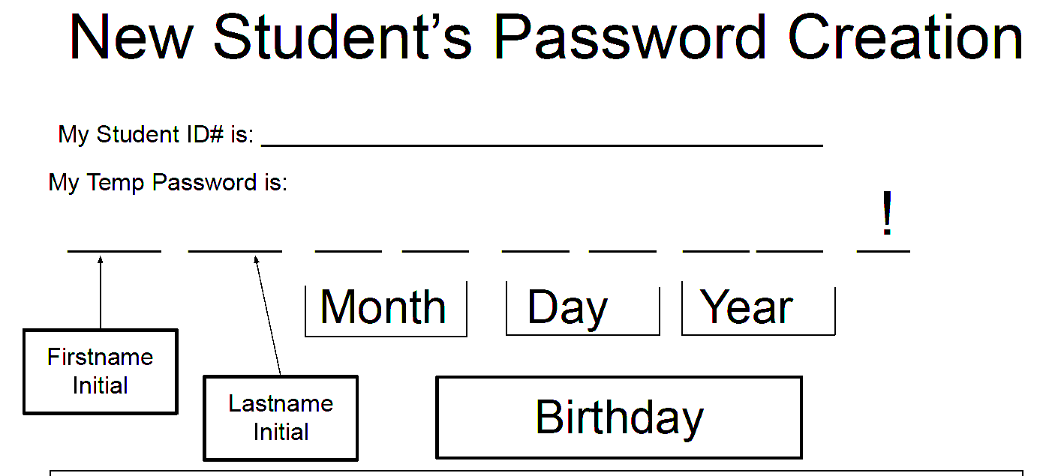
STEP 3: We recommend going through the enroll process, so that if you forget your password you can reset it via text message. This is optional.

If you are an RETURNING SRVUSD STUDENT and have forgotten your password or need to change your password: Please follow the instructions on this sheet - Password

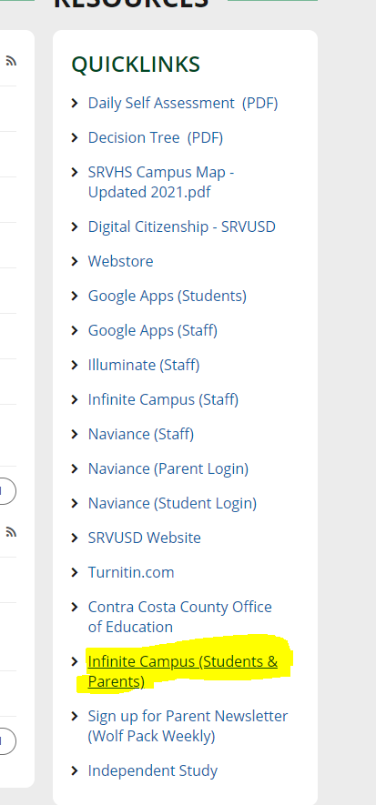
Accessing your Infinite Campus Account
1. Go to https://srvhs.schoolloop.com/

2. Under "Quick Links" click "Infinite Campus (Students & Parents)" to go to an infinite campus >>>>>>>>>>>>>>>>>>>>>>>>>>

3. Choose Students ↓↓↓
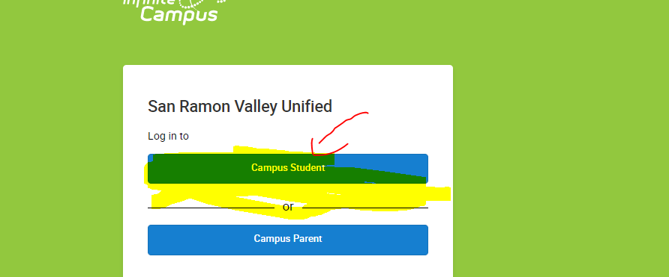

4. Enter student Username which is simply the ID Number and nothing else. Password is the student's password - If they do not know their password check this document - Password

5. Click on Log In ↓↓↓
