How to Log into Haiku

- Go to the following Link: https://srvusd.haikulearning.com/do/account/login
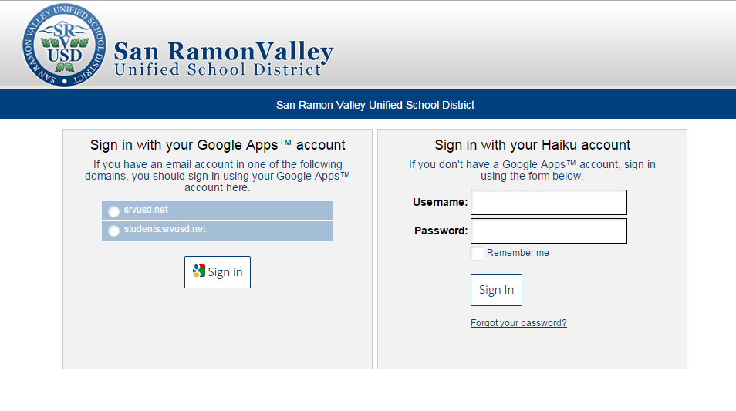

- Select the option to “Sign in with your Google Apps account” on the left side of login widow.

- Click on the “students.srvusd.net” radio button, then click the “Sign in” button.

- In the Google Login window enter your Google Account Email address and password.
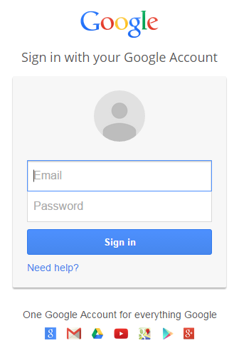

Email: dh.asmith@students.srvusd.net

Password: ********
(this will be your Google Account Password)

