4-year colleges/universities: 76%
2-year colleges: 21%
97% of students in the DVHS class of 2014 went on to college.

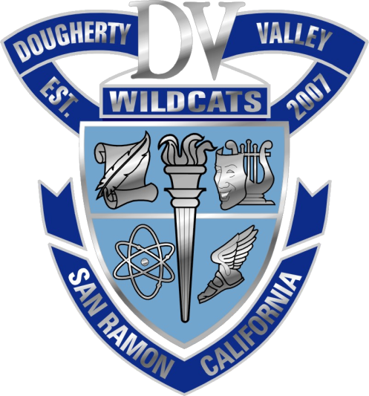

University of California
Berkeley | 47
Davis | 30
Irvine | 12
Los Angeles | 15
Merced | 7
Riverside | 6
San Diego | 11
Santa Barbara | 13
Santa Cruz | 13
Total: | 154

CA Independent 4-yr. Colleges & Universities
Academy of Art SF | 2
Art Center College of Design | 1
California College of the Arts | 1
Dominican | 1
Ex’pressions College | 1
FIDM | 1
John Paul the Great Catholic University | 1
Loyola Marymount | 1
Mills College | 1
Pepperdine | 1
Pomona College | 1
Santa Clara | 2
Saint Mary's College | 2
Stanford | 4
U of the Pacific | 4
U of San Diego | 1
U of San Francisco | 4
USC | 5
Westmont College | 1
Whittier | 1
Total: | 36

California State Universities
Chico | 1
East Bay | 10
Fullerton | 1
Long Beach | 1
Cal Poly Pomona | 1
Sacramento | 1
San Diego | 6
San Francisco | 11
San Jose | 14
Cal Poly SLO | 19
Sonoma | 5
Total: | 70
Out-of-State Colleges and Universities (113):
Arizona State (4), University of Arizona (2), University of Arkansas, Babson College, Bentley University, Boston University, Bringham Young University, Carnegie Mellon (3), Colorado Christian University, Colorado State University, Cornell, Duke (3), Emory (2), Florida College, George Washington University, Harvard, University of Hawaii at Manoa, University of Idaho, University of Illinois, Chicago, University of Illinois, Urbana-Champaign (8), Indiana University at Bloomington, Ithaca College, University of Kansas, Maryland Institute College of Art, MIT, University of Miami (3), University of Michigan, University of Minnesota, Twin Cities (2), University of Nebraska (2), University of Nevada, Reno (7), NYU (4), University of Northern Colorado, Northwestern State University of Louisiana, Northwestern University (2), University of Oklahoma, Oregon State University, University of Oregon, Pennsylvania State University, University of Pennsylvania, University of Pittsburgh, University of Portland (3), Rhode Island School of Design (2), Rose-Hulman Institute of Technology, Saint John’s University, School of the Art Institute of Chicago (4), Seattle University, Smith, St. Bonaventure, St. John’s University, Syracuse University, Texas Christian University (4), University of Texas, Austin (2), Ohio State University, Tulane, U.S. Air Force Academy, U.S. Coast Guard Academy, U.S. Naval Academy, Utah Valley University, Washington University in St. Louis (3), University of Washington (5), Wells College (2), Willamette, William Patterson University, Xavier University

4-year colleges and universities: 76%
2-year colleges and universities: 21%
Out-of-country universities: 1%
Trade/technical schools: .5%

Community Colleges
Chabot | 4
Columbia College | 1
Diablo Valley College | 64
Gavilan College | 1
Laney College | 2
Las Positas College | 19
Los Medanos | 1
Modesto Junior College | 1
Ohlone College | 3
Pasadena City College | 2
Red Rocks Community College | 1
Santa Barbara City College | 3
Santa Monica College | 3
Sierra College | 1
Skyline College | 1
Total: | 107

Out-of-Country Universities | 7
Military | 8
Work | 2
Transition Program | 3
Undecided/Unknown | 3
Total: | 24
Home of the Wildcats
& Traditions in Excellence!

