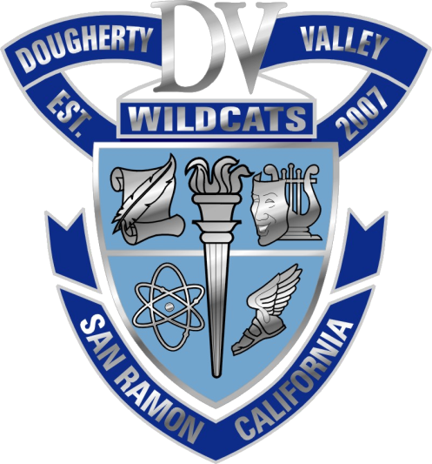
4-year colleges/universities: 76%
2-year colleges: 21%
Trade/Technical School: .5%
97.5% of students in the DVHS class of 2013 went on to college.

University of California
Berkeley | 18
Davis | 18
Irvine | 7
Los Angeles | 13
Merced | 6
Riverside | 7
San Diego | 29
Santa Barbara | 18
Santa Cruz | 12
Total: | 128

CA Independent 4-yr. Colleges & Universities
Academy of Art SF | 2
Azusa Pacific | 1
Biola | 2
CA College of the Arts | 1
Cal Tech | 1
Chapman | 1
Loyola Marymount | 2
Pacific Union | 1
Pepperdine | 1
Pitzer | 1
Santa Clara | 6
Saint Mary's | 4
Stanford | 3
U of the Pacific | 10
U of San Diego | 2
U of San Francisco | 3
USC | 8
Total: | 49

California State Universities
Chico | 1
East Bay | 6
Fullerton | 3
Humboldt | 1
Los Angeles | 1
Monterey Bay | 1
Cal Poly Pomona | 1
Sacramento | 1
San Diego | 4
San Francisco | 11
San Jose | 14
Cal Poly SLO | 19
Sonoma | 3
Total: | 66
Out-of-State Colleges and Universities (111):
Arizona State (7), Babson, Baylor, Boston University (5), Bringham Young, Brown, Carnegie Mellon (2), Centre College, Clark University, Drexel, Duke (2), Emory (2), Fordham, Georgia Institute of Technology (3), Harvard, Howard, Johns Hopkins, Milwaukee School of Engineering, New York University (7), Norfolk State, Northeastern (2), Northern Illinois, Northwestern, Ohio Wesleyan, Oral Roberts, Oregon State, Purdue, Rice, Rutgers, Saint Louis University, Savannah College of Art and Design, School of the Art Institute of Chicago, Southern Methodist, Stevens Institute of Technology, SUNY Maritime, Temple, Texas A&M, Texas Southern, Syracuse, George Washington University, University of Alabama (2), University of Arizona (5), U.S. Air Force Academy, U.S. Military Academy (2), U.S. Naval Academy, University of Arkansas, University of Chicago (2), University of Colorado at Boulder, University of Denver, University of Idaho, University of Illinois at Urbana-Champaign (5), University of Maryland, University of Miami, University of Minnesota, University of Nevada, Reno, University of Northern Colorado, University of Notre Dame, University of Oregon, University of Pennsylvania, University of Pittsburgh, University of Portland (2), University of Washington (7), Vassar, Washington University in St. Louis (2), Willamette, Yale (3)

4-year colleges and universities: 76%
2-year colleges and universities: 21%
Out-of-country universities: 1%
Trade/technical schools: .5%

Community Colleges
Berkeley City College | 1
Chabot | 2
College of San Mateo | 1
De Anza College | 1
Diablo Valley College | 68
Fullerton College | 1
Las Positas College | 19
Los Medanos | 3
San Diego Mesa | 1
Santa Barbara City College | 3
Total: | 100

Out-of-Country Universities | 4
Military | 3
Trade/Tech. School | 2
Work/Travel/Gap Year | 5
Undecided | 3
Total: | 17

